EARLY WARNING BULLETIN FOR FOOD SECURITY

No. 2013/01 IN THE GAMBIA Period: May 1 - 10, 2013

 Government of The Gambia | Produced and Published by the Multidisciplinary Working Group of the AGRHYMET Regional Programme  Focal Point: Department of Water Resources  TEL: (+220) 4227631 / 4224122 / 8905229 - FAX: (+220) 422 50 09  E-MAIL: dwr@mofwrnam.gov.gm / WEB: www.mofwrnam.gov.gm | AGRHYMET Regional Programme

1. PROGRESS OF RAINY SEASON

The surface position of the Inter-Tropical Convergence Zone (ITCZ) (imaginary boundary separating warm and moist winds from and dry northerly winds over West Africa) during the dekad was on average above the Gambia. Last year during the same period it was positioned south of the Gambia, hence indicating that the rain bearing winds have progressed early north-wards over our sub-region compared to last year at the same period.

Mean while, countries like Mali, Burkina-Faso, Niger and Gulf of Guinea States ) lies to the south of the ITCZ experienced convective cloud development resulting to thunderstorms and rain. However, occurrences were mostly scattered and limited to the afternoons and nights. North of the ITCZ, by contrast, was rather stable and dry with patches of dust haze observed mostly over Mauritania and northern Mali where visibility of 6-8km was reported. Early morning mist/fog featured over Gambia and Senegal during much of the dekad.

  - weather outlook for the next dekad

As the north wards migration of the ITCZ has began much more cloudiness is expected during the next dekad

2. RAINFALL SITUATION

No rainfall was recorded throughout the country during this dekad. This depicts the same situation as in last year (2012).

3. AGROMETEOROLOGICAL SITUATION

Mean extreme temperatures during this dekad followed a West-East gradient (figure 1) ranging from 26.0 ºC in Banjul in west to 32.5 ºC at Fatoto in the East. Likewise the lowest temperature of 18.3 ºC was recorded at Yundum and the highest maximum temperature of 46 ºC was recorded in Jenoi. The prevailing cool sea breezes are a contributing factor in the temperature trend.

With the influence of the sea breeze mean average relative humidity (RH) was highest in the areas close to the coast and lowest further inland areas (figure 1). They ranged from 70% in the west to 40% in the East.

Winds during the dekad were generally moderate to light in speed.

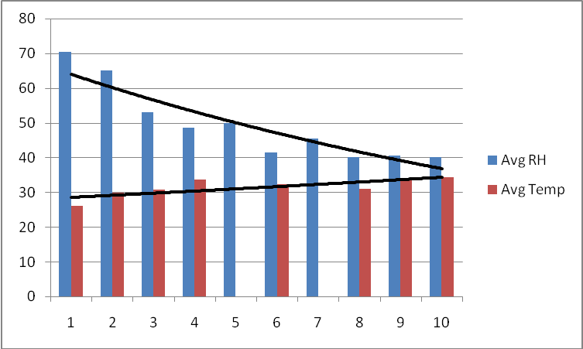
Figure 1: Relative and extreme temperature trends

4. AGRICULTURAL SITUATION

The major farmer on-field activities are field clearing, acquisition and preparation of seeds and the repair of farming implements. Female farmers are still busy harvesting their vegetables.

Composition of MWG:  Department of Water Resources  Planning Services - Department of Agriculture (DOA)  Communication, Extension & Education Services - DOA  Animal Health & Production Services - DOA  Plant Protection Services - DOA  National Environment Agency | Direct your comments and questions to:  The Director  Department of Water Resources  7 Marina Parade, Banjul  The Gambia  Tel: (+ 220) 422 76 31 / 422 41 22 / 890 52 29  Email: dwr@mofwrnam.gov.gm

